

CSE316 PROJECT OF OPERATING SYSTEM(OS)

PROGRAMMING ASSESMENT

Submitted by :Rohit Kataria

Reg. ID :11810799

Section and Group: K18SP and Group1

Roll no.: 23

Email add.: mrkataria087@gmail.com

Submitted to : Isha Sharma(23888)

Course: B.Tech(CSE) 2nd year

GITHUB link: <https://github.com/mrkataria>

QUESTION Design a scheduling program to implements a Queue with two levels: Level 1 : Fixed priority preemptive Scheduling Level 2 : Round Robin Scheduling For a Fixed priority preemptive Scheduling (Queue 1), the Priority 0 is highest priority. If one process P1 is scheduled and running, another process P2 with higher priority comes. The New process (high priority) process P2 preempts currently running process P1 and process P1 will go to second level queue. Time for which process will strictly execute must be considred in the multiples of 2.

All the processes in second level queue will complete their execution according to round robin scheduling. Consider: 1. Queue 2 will be processed after Queue 1 becomes empty. 2. Priority of Queue 2 has lower priority than in Queue 1.

CODE

#include <bits/stdc++.h>

using namespace std;

struct Process_Data

{

int Num;

int Pid; //Process Id

int A_time; //Process Arrival Time

int B_time; //Process Bruest Time

int Priority; //Process Priority

int F_time; //Process Finish Time

int R_time; //Process Remaining Time During Execution

int W_time; //Waiting Time

int S_time; //Process start Time

int Res_time;

};

struct Process_Data current;

typedef struct Process_Data P_d ;

bool idsort(const P_d& x , const P_d& y)

{

return x.Pid < y.Pid;

}

bool arrivalsort( const P_d& x ,const P_d& y)

{

if(x.A_time < y.A_time)

return true;

else if(x.A_time > y.A_time)

return false;

if(x.Priority < y.Priority)

return true;

else if(x.Priority > y.Priority)

return false;

if(x.Pid < y.Pid)

return true;

return false;

}

bool Numsort( const P_d& x ,const P_d& y)

{

return x.Num < y.Num;

}

struct comPare

{

bool operator()(const P_d& x ,const P_d& y)

{

if( x.Priority > y.Priority )

return true;

else if( x.Priority < y.Priority )

return false;

if( x.Pid > y.Pid )

return true;

return false;

}

};

void my_check(vector<P_d> mv)

{

for(unsigned int i= 0; i < mv.size() ;i++)

{

cout<<" Pid :"<<mv[i].Pid<<" _time : "<<mv[i].A_time<<" B_time : "<<mv[i].B_time<<" Priority : "<<mv[i].Priority<<endl;

}

}

int main()

{

int i;

vector< P_d > input;

vector<P_d> input_copy;

P_d temp;

int pq_process = 0; // for PQ process

int rq_process = 0; // for RQ process

int A_time;

int B_time;

int Pid;

int Priority;

int n;

int clock;

int total_exection_time = 0;

cin>>n;

for( i= 0; i< n; i++ )

{

cin>>Pid>>A_time>>B_time>>Priority;

temp.Num = i+1;

temp.A_time = A_time;

temp.B_time = B_time;

temp.R_time = B_time;

temp.Pid = Pid;

temp.Priority = Priority;

input.push_back(temp);

}

input_copy = input;

sort( input.begin(), input.end(), arrivalsort );

total_exection_time = total_exection_time + input[0].A_time;

for( i= 0 ;i< n; i++ )

{

if( total_exection_time >= input[i].A_time )

{

total_exection_time = total_exection_time +input[i].B_time;

}

else

{

int diff = (input[i].A_time - total_exection_time);

total_exection_time = total_exection_time + diff + B_time;

}

}

int Ghant[total_exection_time]={0};

for( i= 0; i< total_exection_time; i++ )

{

Ghant[i]=-1;

}

priority_queue < P_d ,vector<Process_Data> ,comPare> pq;

queue< P_d > rq;

int cpu_state = 0;

int quantum = 4 ;

current.Pid = -2;

current.Priority = 999999;

for ( clock = 0; clock< total_exection_time; clock++ )

{

for( int j = 0; j< n ; j++ )

{

if(clock == input[j].A_time)

{

pq.push(input[j]);

}

}

if(cpu_state == 0)

{

if(!pq.empty())

{

current = pq.top();

cpu_state = 1;

pq_process = 1;

pq.pop();

quantum = 4;

}

else if(!rq.empty())

{

current = rq.front();

cpu_state = 1;

rq_process = 1;

rq.pop();

quantum = 4;

}

}

else if(cpu_state == 1)

{

if(pq_process == 1 && (!pq.empty()))

{

if(pq.top().Priority < current.Priority )

{

rq.push(current);

current = pq.top();

pq.pop();

quantum = 4;

}

}

else if(rq_process == 1 && (!pq.empty()))

{

rq.push(current);

current = pq.top();

pq.pop();

rq_process = 0;

pq_process = 1;

quantum = 4 ;

}

}

if(current.Pid != -2)

{

current.R_time--;

quantum--;

Ghant[clock] = current.Pid;

if(current.R_time == 0)

{

cpu_state = 0 ;

quantum = 4 ;

current.Pid = -2;

current.Priority = 999999;

rq_process = 0;

pq_process = 0;

}

else if(quantum == 0 )

{

rq.push(current);

current.Pid = -2;

current.Priority = 999999;

rq_process = 0;

pq_process = 0;

cpu_state=0;

}

}

}

sort( input.begin(), input.end(), idsort );

for(int i=0;i<n;i++)

{

for(int k=total_exection_time;k>=0;k--)

{

if(Ghant[k]==i+1)

{

input[i].F_time=k+1;

break;

}

}

}

for(int i=0;i<n;i++)

{

for(int k=0;k<total_exection_time;k++)

{

if(Ghant[k]==i+1)

{

input[i].S_time=k;

break;

}

}

}

sort( input.begin(), input.end(), Numsort );

for(int i=0;i<n;i++)

{

input[i].Res_time=input[i].S_time-input[i].A_time;

input[i].W_time=(input[i].F_time-input[i].A_time)-input[i].B_time;

}

for(int i=0;i<n;i++)

{

cout<<input[i].Pid<<" "<<input[i].Res_time<<" "<<input[i].F_time<<" "<<input[i].W_time<<endl;

}

return 0;

}

The code is running in the dev c++ compiler:

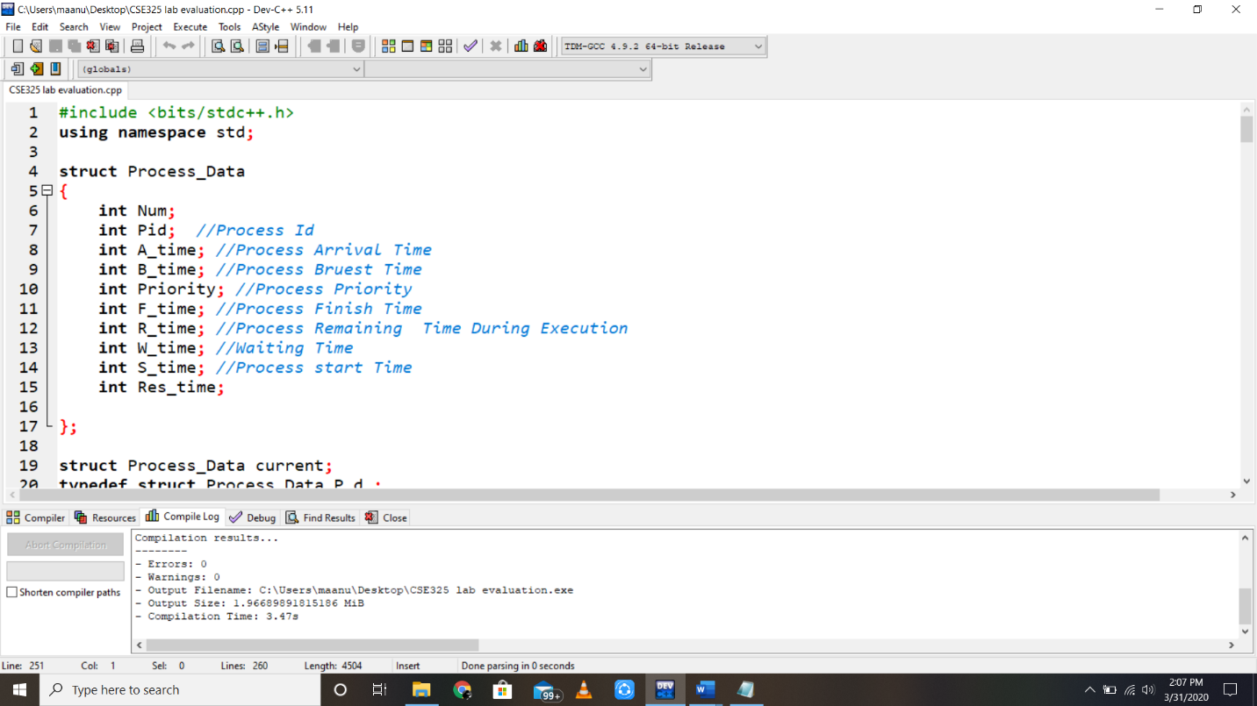

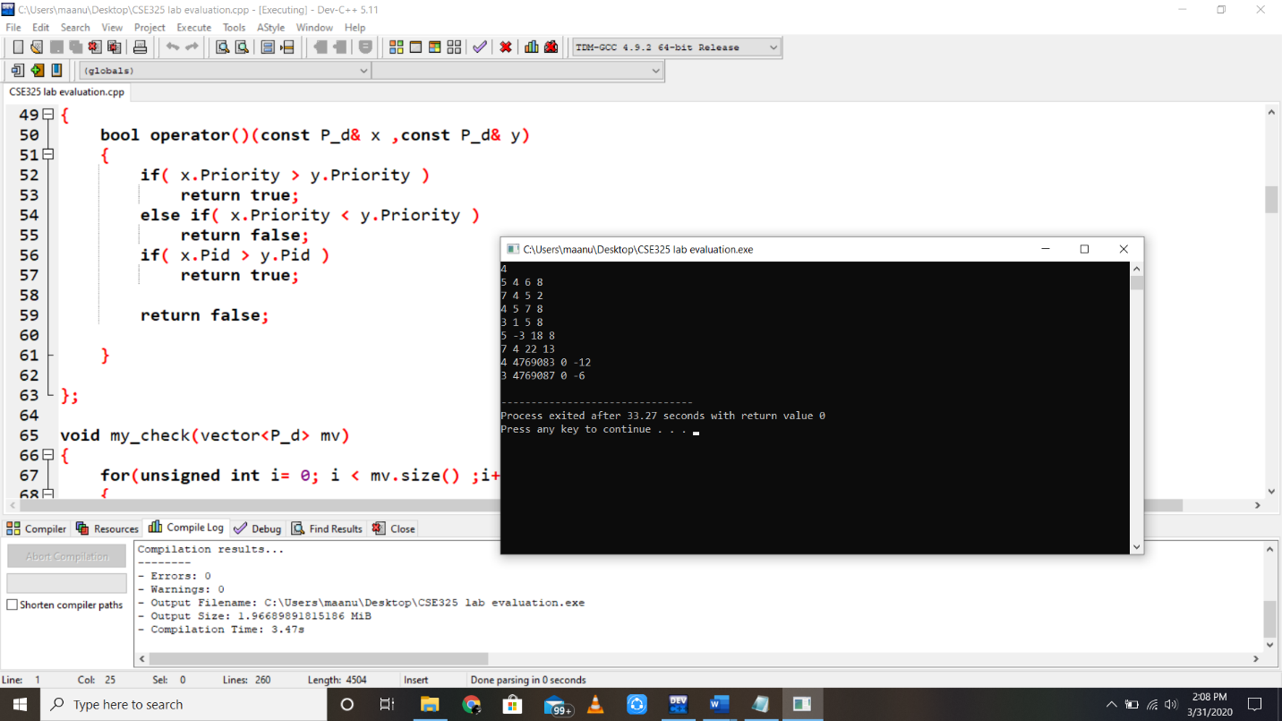

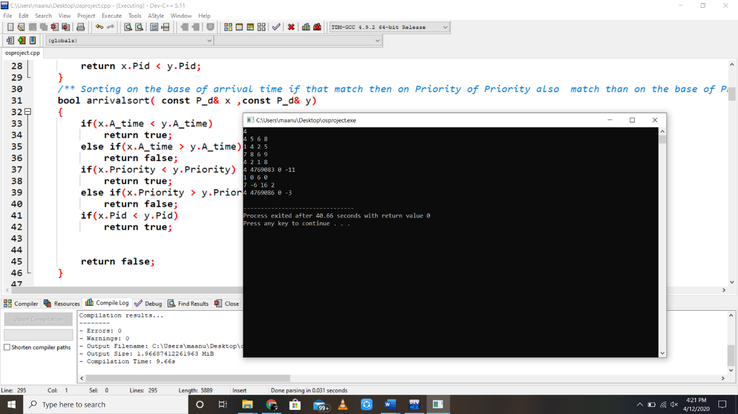

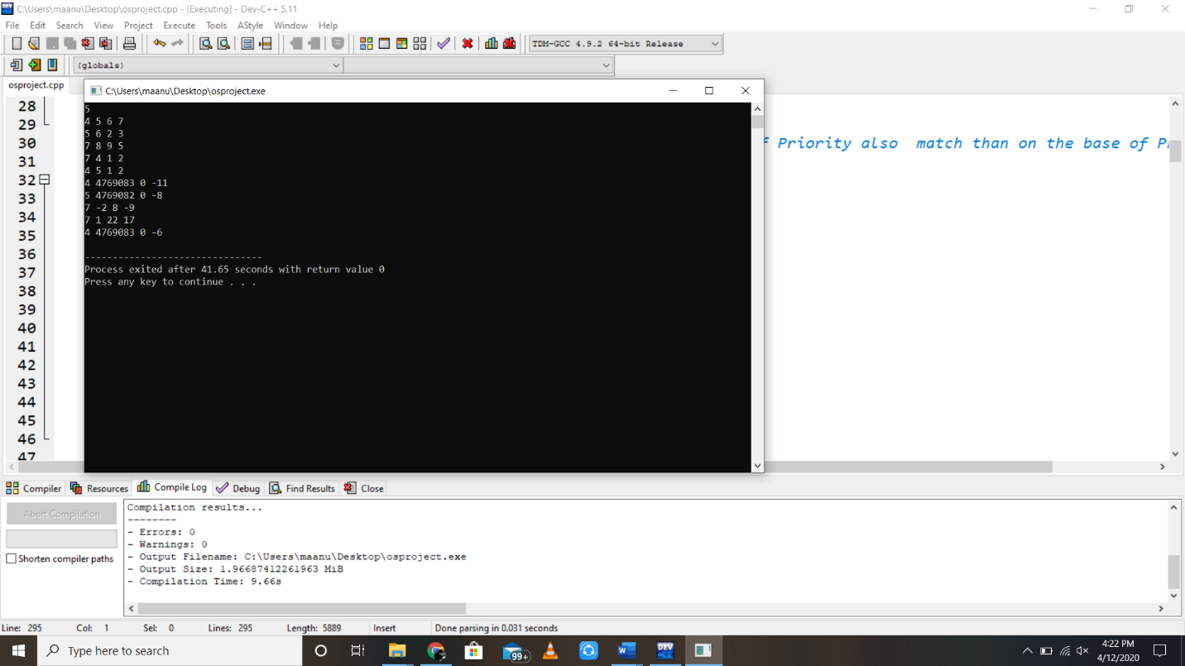

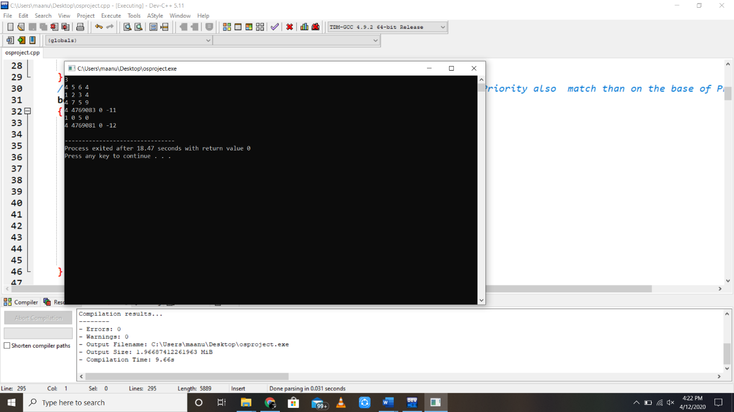

Screenshots of the running code.

I have taken input element and run it.